**Orienteering Merit Badge Week #3 Study sheet**

**Control Feature Symbols**

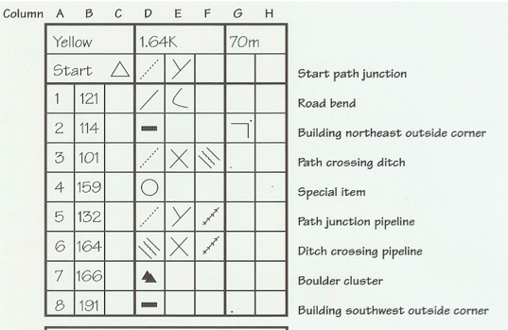

**Practical: Orienting the Map**

Definition: lining up the map with the real world

1. How to orient your map if the top of the map is true north and you are in New England: (you will have to demonstrate this)
   1. Turn the compass bezel to 15 degrees.
   2. Line up the side of the compass with the side of the map.
   3. Turn the compass and map **together** until the compass arrow is inside the orienting arrow.
2. How to orient your map if the top of the map is magnetic north:
   1. Turn the compass bezel to 0 degrees
   2. Follow #2 and #3 above.

**Techniques**: (these will be matching)

**Handrail**: linear feature (fence, trail, pipeline) that roughly travels where you want to go.

**Collecting features**: recognizable map features you should pass if you are on the right track

**Catching feature**: recognizable map feature you will reach if you go too far

**Aiming off:** purposely aiming to one side of a junction, so you will know which way to go when you reach a recognizable linear feature.

**Attack point**: recognizable map feature close to the control point from which you can zero in on the control

**Contouring:** Following a contour line in a curved, level path to a destination rather than going in a straight line which involves steep climbing and descending