**Angle of Declination**

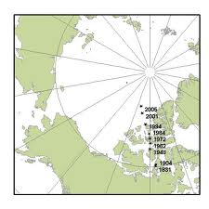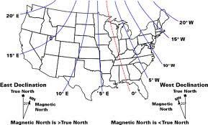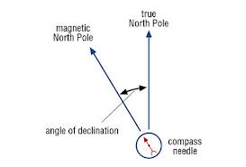

What is the angle of declination in Rhode island?

________________________________

What is the angle of declination in Washington state?

__________________

What does the moving point represent?

________________________________________________